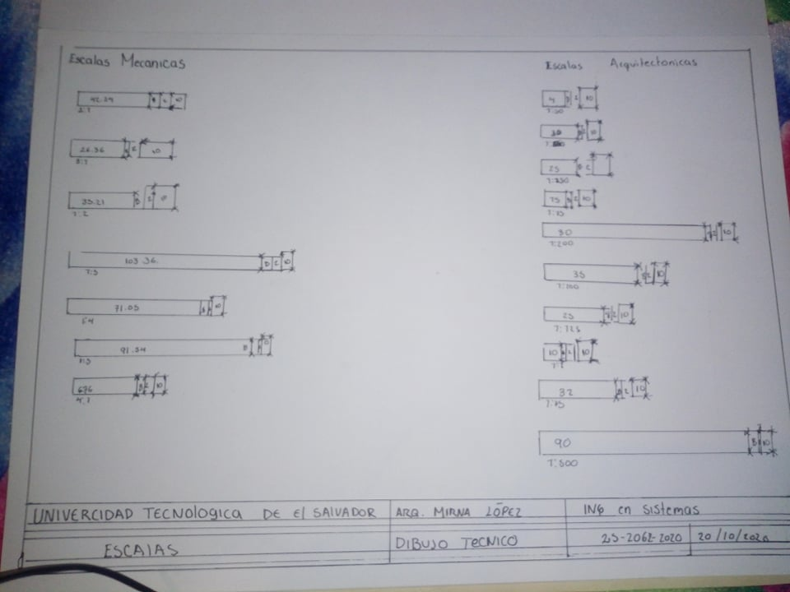

2520622020 krissia magali dueñas Molina